SENTIMEN ANALIS KUHP PASAL 44 AYAT 1

UPAYA PENANGGULANGAN TINDAK PIDANA KEKERASAN DALAM RUMAH TANGGA DI WILAYAH SUMATERA BARAT

Oleh:Neni Harisah Muhammad Byon Jurusan Teknologi Informasi Prodi D3 Manajemen informatika

e-mail: [putripulungan04@gmail.com](mailto:putripulungan04@gmail.com) [muhamamdbyon31@gmail.com](mailto:muhamamdbyon31@gmail.com)

***Abstract***— **This document gives formatting instructions for authors preparing papers for publication in the International Journal on Informatics Visualization. The authors must follow the instructions given in the document for the papers to be published. You can use this document as both an instruction set and a template into which you can type your own text. Please leave the space above the title empty. Space is intentionally spared for the journal title. JOIV requires the authors to cite at least twenty sources, and all the citations in-text must be synchronized with references. It is highly recommended to use a citation manager to ensure citation synchronization. The word number in abstract should be within 230-250 words and consists of objectives, materials, method, results, and implication for further research.**

***Keywords***— **Put your keywords here; keywords are separated by a semicolon.**

*Manuscript received 15 Oct. 2020; revised 29 Jan. 2021; accepted 2 Feb. 2021. Date of publication 17 Feb. 2021.*

*International Journal on Informatics Visualization is licensed under a Creative Commons Attribution-Share Alike 4.0 International License.*

**

1. Introduction

Sentimen analisis (sentiment analysis) adalah proses menganalisis potongan text secara online dengan menentukan nada emosional yang mereka bawa, apakah itu positif, negatif atau netral. Sederhananya, analisis sentimen dapat membantu untuk menemukan sikap penulis terhadap suatu topik.

alasan mengambil data dari twitter karena data itu berfariatif dan selalu up to date setiap

menit nya sehingga mampu menghasilkan nilai akurasi yg lebih akurat.

Page Layout

An easy way to comply with the conference paper formatting requirements is to use this document as a camera-ready template.

1. *Page Layout*

Your paper must use a page size corresponding to A4 which is 210mm (8.27") wide and 297mm (11.69") long. The margins must be set as follows:

* Top = 19mm (0.75")
* Bottom = 28mm (1.1")
* Left = Right = 14.32mm (0.56")

Your paper must be in two column formats with a space of 8.5mm (0.34") between columns.

1. Page Style

All paragraphs must be indented. All paragraphs must be justified, i.e., both left-justified and right-justified.

1. *Text Font of Entire Document*

The entire document should be Times New Roman at 10 points in size. Other font type and size may be used if needed for special purposes. Recommended font type and sizes are shown in Table 1.

TABLE I  
Font Sizes for Papers

|  |  |  |  |
| --- | --- | --- | --- |
| **Font Size** | **Appearance (in Time New Roman or Times)** | | |
| **Regular** | **Bold** | **Italic** |
| 8 | table caption (in Small Caps), figure caption, reference item |  | reference item (partial) |
| 9 | Institution, author email address, and cell in a table | abstract body | abstract heading (also in Bold)  author affiliation |
| 10 | level-1 heading (in Small Caps),  paragraph |  | level-2 heading,  level-3 heading, |
| 12 | author name |  |  |
| 18 | title |  |  |

1. *Title and Author Details*

Title must be Times New Roman at 18 points in size. Author name must be Times New Roman at 12 points in size. Author affiliation must be Times New Roman at 9 points in size and *italic*. Corresponding email address must be Times New Roman at 9 points in size. All title and author (s) affiliation must be in single-column format and must be centered.

Every word in a title must be capitalized except for short minor words such as “a”, “an”, “and”, “as”, “at”, “by”, “for”, “from”, “if”, “in”, “into”, “on”, “or”, “of”, “the”, “to”, “with”.

Author details must not show any professional title (e.g., Managing Director), any academic title (e.g., Dr.) or any membership of any professional organization.

To avoid confusion, the family name must be written as the last part of each author name (e.g., John A.K. Smith). Each affiliation must include, at the very least, the name of the company and the name of the country where the author is based (e.g., Causal Productions Pty Ltd, Australia).

1. *Section Headings*

No more than 3 levels of headings should be used. All headings must be in 10pt font. Every word in a heading must be capitalized except for short minor words as listed in Section III-B.

1. *Level-1 Heading*: A level-1 heading must be in Small Caps, centered and numbered using uppercase Roman numerals. For example, see heading “III. Page Style” of this document. The two level-1 headings which must not be numbered are “Acknowledgment” and “References”.
2. *Level-2 Heading:* A level-2 heading must be in Italic, left-justified and numbered using an uppercase alphabetic letter followed by a period. For example, see heading “C. Section Headings” above.
3. *Level-3 Heading:* A level-3 heading must be indented, in Italic and numbered with an Arabic numeral followed by a right parenthesis. The level-3 heading must end with a colon. The body of the level-3 section immediately follows the level-3 heading in the same paragraph. For example, this paragraph begins with a level-3 heading.

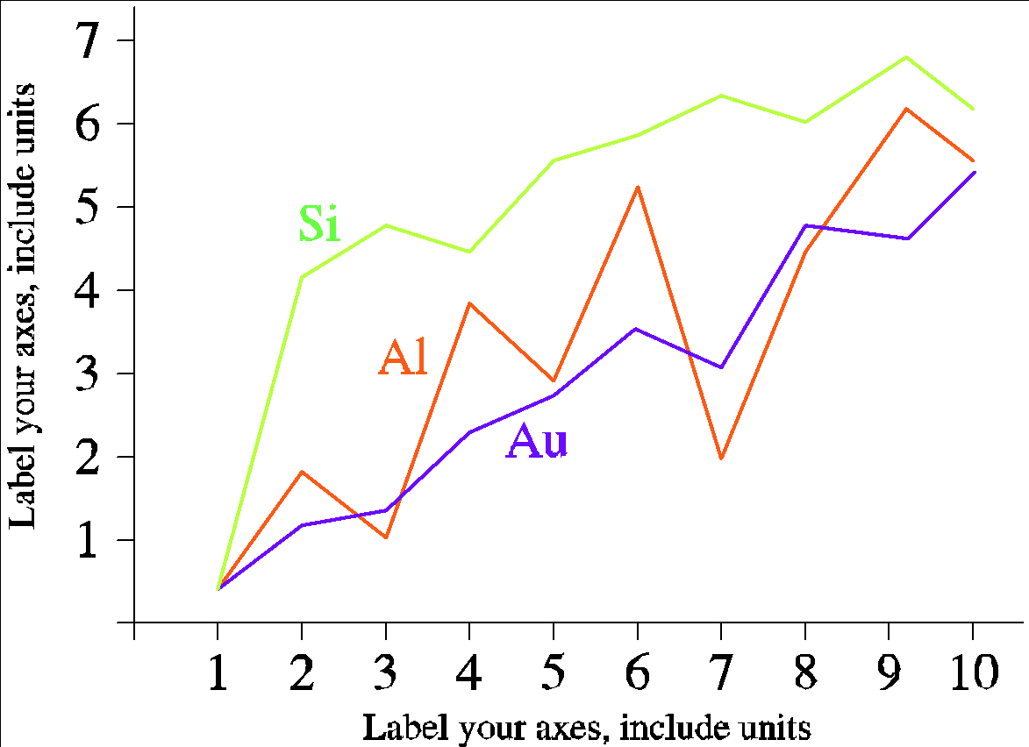

Fig. 1 A sample line graph using colors which contrast well both on screen and on a black-and-white hardcopy

1. *Figures and Tables*

Figures and tables must be centered in the column. Large figures and tables may span across both columns. Any table or figure that takes up more than 1 column width must be positioned either at the top or at the bottom of the page.

Graphics may be full color. All colors will be retained on the CDROM. Graphics must not use stipple fill patterns because they may not be reproduced properly. Please use only *SOLID FILL* colors which contrast well both on screen and on a black-and-white hardcopy, as shown in Fig. 1.

Fig. 2 shows an example of a low-resolution image which would not be acceptable, whereas Fig. 3 shows an example of an image with adequate resolution. Check that the resolution is adequate to reveal the important detail in the figure.

Please check all figures in your paper both on screen and on a black-and-white hardcopy. When you check your paper on a black-and-white hardcopy, please ensure that:

* the colors used in each figure contrast well,
* the image used in each figure is clear,
* all text labels in each figure are legible.

1. *Figure Captions*

Figures must be numbered using Arabic numerals. Figure captions must be Times New Roman at 8 points in size. Captions of a single line (e.g., Fig. 2) must be centered whereas multi-line captions must be justified (e.g., Fig. 1). Captions with figure numbers must be placed after their associated figures, as shown in Fig. 1.



Fig. 2 Example of an unacceptable low-resolution image

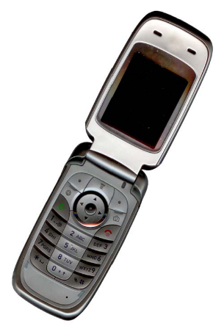

Fig. 3 Example of an image with acceptable resolution

1. *Table Captions*

Tables must be numbered using uppercase Roman numerals. Table captions must be centred and in 8 pt Regular font with Small Caps. Every word in a table caption must be capitalized except for short minor words as listed in Section III-B. Captions with table numbers must be placed before their associated tables, as shown in Table 1.

1. *Page Numbers, Headers and Footers*

Page numbers, headers and footers must not be used.

1. *Links and Bookmarks*

All hypertext links and section bookmarks will be removed from papers during the processing of papers for publication. If you need to refer to an Internet email address or URL in your paper, you must type out the address or URL fully in Regular font.

1. *Equations*

Equations should be placed flush-left with the text margin. Equations are centered and numbered consecutively starting from 1 as follows

 (1)

1. *References*

The heading of the References section must not be numbered. All reference items must be Times New Roman at 8 points in size. Please use Regular and Italic styles to distinguish different fields as shown in the References section. Number the reference items consecutively in square brackets (e.g. [1]). The examples of reference items of different format are as follows:

* Basic format for books [1], [2]
* Basic format for periodicals [3], [4], [5]
* Basic format for reports [6], [7]
* Basic format for handbooks [8], [9]
* Basic format for books (when available online) [10], [11], [12], [13]
* Basic format for journals (when available online) [14], [15], [16]
* Basic format for papers presented at conferences (when available online) [17]
* Basic format for reports and handbooks (when available online) [18], [19]
* Basic format for computer programs and electronic documents (when available online) [20]
* Basic format for patents (when available online) [21]
* Basic format for conference proceedings (published) [22]
* Example for papers presented at conferences (unpublished) [23]
* Basic format for patents [24]
* Basic format for theses (M.S.) and dissertations (Ph.D.) [25], [26]
* Basic format for the most common types of unpublished references [27], [28], [29]
* Basic formats for standards [30], [31].

1. Conclusion

Sesuai dengan pembahasan pokok permasalahan tersebut diatas, maka dapat ditarik simpulan bahwa Kekerasan Dalam Rumah Tangga adalah setiap perbuatan sewenangwenang baik secara fisik maupun non fisik yang dilakukan oleh seorang terhadap orang lain yang berakibat timbulnya kesengsaraan atau penderitaan secara fisik, seksual psikologi atau pelantaran rumah tangga termasuk ancaman untuk melakukan perbuatan, pemaksaan atau perampasan kemerdekaan secara melawan hukum dalam ruang lingkup rumah tanggga.

Adapun faktor-faktor yang mempengaruhi tindak kekerasan dalam rumah tangga adalah lemahnya pengetahuan/Pendidikan termasuk pengetahuan hokum, lemah dan kuatnya perekonomi Keluarga, Kultur social, Perselingkuhan/Orang Ketiga. Dampak yang ditimbulkan dari kekerasan dalam rumah tangga adalah kekerasan dalam bentuk fisik, kekerasan dalam bentuk psikis, Stigma buruk yang melekat pada korban. Kendala yang dihadapi dalam penanganan kekerasan dalam rumah tangga antara lain masih kuatnya keterkaitan dan ketergantungan istri terhadap suaminya dan malu kalau kasusnya diketahui orang lain. Selain itu, persoalan ekonomi juga faktor utama penyebab terjadinya kekerasan dalam rumah tangga karena apabila mereka melaporkan kepihak berwajib mereka akan takut nantinya tidak dinafkahi oleh suaminya karena masih menggantungkan materi kepada suaminya dan takut apabila mereka sampai bercerai nantinya mereka tidak bisa melanjutkan nasib hidupnya apabila nantinya mereka bercerai. Upaya penghapusan Kekerasan Dalam Rumah Tangga harus dilakukan secara terus menerus baik itu dilakukan oleh semua pihak. Baik pemerintah, penegak hukum, organisasi masyarakat, dan organisasi agama karena kekerasan dalam rumah tangga bertentangan dengan perikemanusiaan, serta masyarakat tidak lupa pula upaya penanggulangan dapat dilaksanakan dengan pemberdayaan korban itu sendiri agar jangan sampai kekerasan itu terjadi ataupun terulang kembali dalam lingkup rumah tangga khususnya di Kabupaten Buleleng.

Nomenclature

a specific surface area m2m-3

x length co-ordinate m

Greek letters

α heat transfer coefficient Wm-2K-1

τ residence time s

Subscripts

i inlet

e equilibrium

Acknowledgment

We would like to thank Causal Productions for permits to use and revise the template provided by Causal Productions. Original version of this template was provided by courtesy of Causal Productions (www.causalproductions.com).

References

Bungin, Burhan. 2001. Metodelogi Penelitian Kualitatif. Jakarta: PT Raja Grafindo Persada. Gultom, Maidin. 2012. Perlindungan Hukum Terhadap Anak dan Perempuan. Bandung: PT Refika Aditama. Luhulima, Achie Sudiarti.2000. Pemahaman BentukBentuk Tindak Kekerasan Terhadap Perempuan dan alternatif Pemecahannya. Jakarta: P.T Alumni. Netra. 1974. Metodelogi Penelitian. Usaha Nasional Surabay